Jarvis Emulator  
User Manual  
COP 4331, Fall 2015

**Modification History**

|  |  |  |  |
| --- | --- | --- | --- |
| **Version** | **Date** | **Who** | **Comment** |
| v0.0 | 12/2/2015 | Julian Rojas | Created Document |
| v1.0 | 12/3/2015 | Manuel Gonzalez | Added “What everything means” and Step by Step Section |

**Team Members:**

* Jimmy Lam
* Julian Rojas
* Manuel Gonzalez
* Robin Schiro

**System Description**

Jarvis is a Windows desktop application that can detect and recognize users as they enter or exit the room, and can respond to the users’ voice commands though speech construction. It can also perform tasks for users, such as opening other applications, taking a picture of the users, displaying relevant information to the users through website RSS feeds, and logging users out of their computer. The front end GUI will allow the users to set up their profiles, train Jarvis to remember their faces, and configure other settings of the application. It will also display visuals to let the users know it is speaking to the users.

Quick Video showing JARVIS:

https://www.youtube.com/watch?v=ayJ3H3ooHEc&feature=youtu.be

**JARVIS Requirements**

* Windows OS
* Microphone
* Camera
* Internet Connection

**Features of JARVIS**

* Recognize Commands
* Edit Profile
* Detect and Recognize Face
* Log out
* Take picture
* Open/close application
* Pull information from related websites
* Voice response
* Create a profile

**List of Commands**

Any command has to be started by saying “OK Jarvis.”

* **Open** **=** Jarvis will open an application if the user has already given the file path.
* **Hi Jarvis =** Jarvis will greet the user back
* **Log out =** Jarvis will log user out
* **Close =** Jarvis will close the application if it’s running.
* **Update =** Jarvis will give you an “update” of your favorite website. (News/blogs)
* **Take my picture =** Jarvis will take a shot of your face
* **Snap =** Jarvis will take a shot of your face
* **Cheese =** Jarvis will take a shot of your face
* **Selfie =** Jarvis will take a shot of your face
* **How is the weather =** Jarvis will tell you the weather conditions.

**What everything means**

Once you open JarvisEmulator.exe, Jarvis’ main window will show up.

The main window contains two tabs:

1. “Configuration” tab

This tab is used to create, edit and delete profiles. When editing profiles, it allows to add and delete the user specific trigger words as well as training the user, which is essential for user recognition using the camera.

Also, from this tab you can change the zip code used for the weather forecast as well as the location of the training images for user recognition.

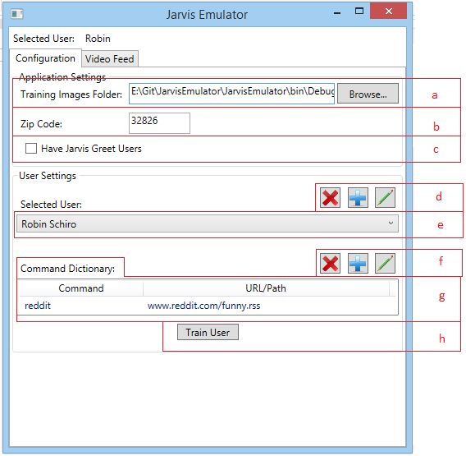

* 1. This text box shows the location of the Training Images, this can be edited using the “Browse” button next to it.
  2. This text box shows the zip code used for the weather forecast. It can be edited at any time.
  3. When toggling this check box on, Jarvis will greet any user it recognizes.
  4. This is used to delete ( ), add ( ) and edit ( ) users.
  5. This dropdown menu selects the user currently being used when adding trigger words and training the user.
  6. This is used to delete ( ), add ( ) and edit ( ) user specific trigger words.
  7. A list with all the user trigger words and their respective paths. When deleting trigger words, it has to be selected first from this list.
  8. The “Train User” button.

1. “Video Feed” tab

This tab is meant to provide the user more information about the inner workings of the face recognition algorithm. It shows the camera feed being used to detect the user’s faces and it can show the detection rectangles that enclose them.

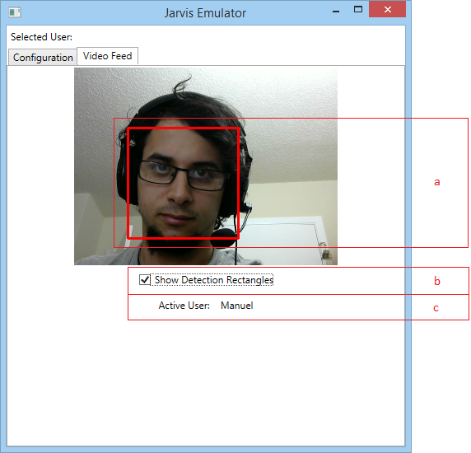

* 1. Detection Rectangles that highlight the detected faces.
  2. Toggle this off to remove the Detection Rectangles from the camera feed images.
  3. This label shows the current user being detected.

*Trigger words* are used to customize user experience among different users. Every time you want to open or close an application, or update RSS feed or open a website you’ll have to use a trigger word that describes the URL to the website’s RSS feed, the website’s webpage, or a path to your application.

The syntax to command Jarvis to do this type of actions is:

“OK, Jarvis.” <Command> <Trigger word>

As an example, let’s use the previous image that outlines the “Configuration” tab. My first name is Manuel. I go in front of the camera, wait for Jarvis to recognize me and say “Ok Jarvis, update reddit”. “update” is a command word from the list of commands described previously, and “reddit” is in my “Command dictionary” list. Jarvis will TELL me what that RSS feed has inside using the URL the “reddit” command picture is pointing to.

**Step by Step User Instructions**

**Creating a profile**

Jarvis will not open or close any application, nor will it update a webpage’s RSS or open a URL in a browser without a recognized user. Initially, no user will be registered in the system.

To add new users:

1. Press the button to the right of the “Selected User:” label at the “Configuration” tab.
2. A new window will appear. Enter the first and last name of the new user and click the “Ok” button.

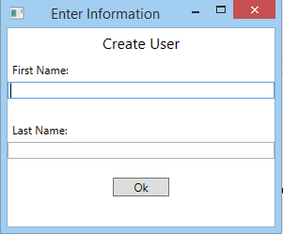

A new user will be created. Remember that you can always delete any user by selecting it from the dropdown menu after the “Selected User:” label and clicking the  button. Also, you can always edit any user’s name by selecting it from the dropdown menu after the “Selected User:” label and clicking the  button, changing the information and clicking the “Ok” button.

**Training a user**

You will realize right after you’ve created a new user, this user will not be recognized and nothing will happen when he is inside the camera’s view. This is because Jarvis does not know how he looks. You’ll have to train the user to make sure Jarvis knows you.

To train users:

1. Select the user to be trained. NOTE: Make sure you are training the right user, the selected user will always be shown at the top of the window. DO NOT give Jarvis different faces for the same user, IT WILL REALLY CONFUSE HIM.

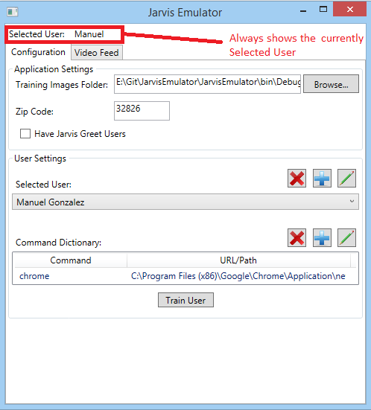

1. Click the “Train User” button in the “Configuration” tab.
2. Press “Yes”, then “Ok”.
3. 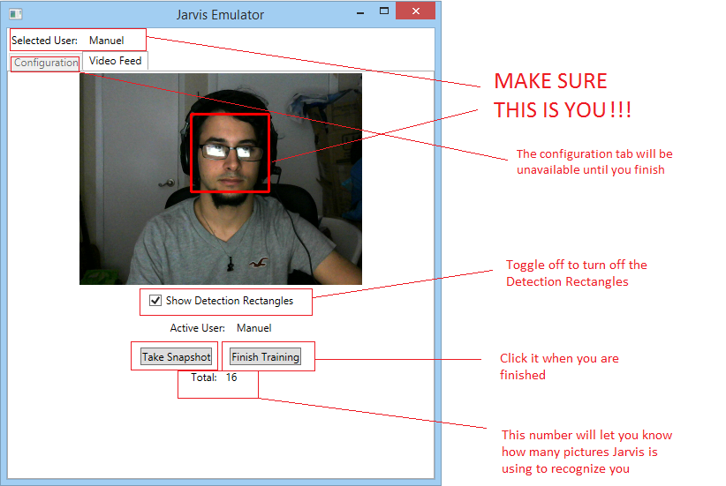Now you are in training mode. Take some pictures using the “Take Snapshot” button with the most different lighting conditions, angles, minimizing the number of pictures as much as you can.
4. Click the Finish Training when you think you are done.

At this point Jarvis should recognize you. Go to the “Video Feed” tab to check whether or not is recognizing you. If it is not, continue training, taking snapshots at the specific times that is not recognizing you to maximize efficiency.

Take into account that if you take too many pictures, Jarvis may have a hard time to start recognizing faces, because it has to through all those faces every time it looks at a face, so, keep the picture count as low as you can.

**Adding trigger words**

Jarvis recognizes you, but you need to tell him what is it that you are going to be asking from him, specifically, you have to tell let him know what is the URL to the websites you want to get the RSS from, or the URL of the website you want to open, or the path to the application you want to open or close.

To add a trigger word to the “Command Dictionary”:

1. Click the button next to the “Command Dictionary” label in the “Configuration” tab.
2. Write the Trigger Word and the URL/Path of your RSS/Webpage/Application (.exe) and click Ok.

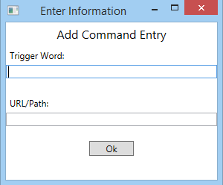

Also, you can always come back and delete a trigger word by selecting it from the “Command Dictionary” list and pressing the  button. Also you can change the trigger word or the URL/Path by selecting the trigger word from the “Command Dictionary” list and pressing the  button.